Supplemental Figure 1. Number of respondents per week of the study period (43 countries, 2020).

Supplemental Figure 2. Kappa Correlations Between Non-Pharmaceutical Interventions (43 countries, 2020).

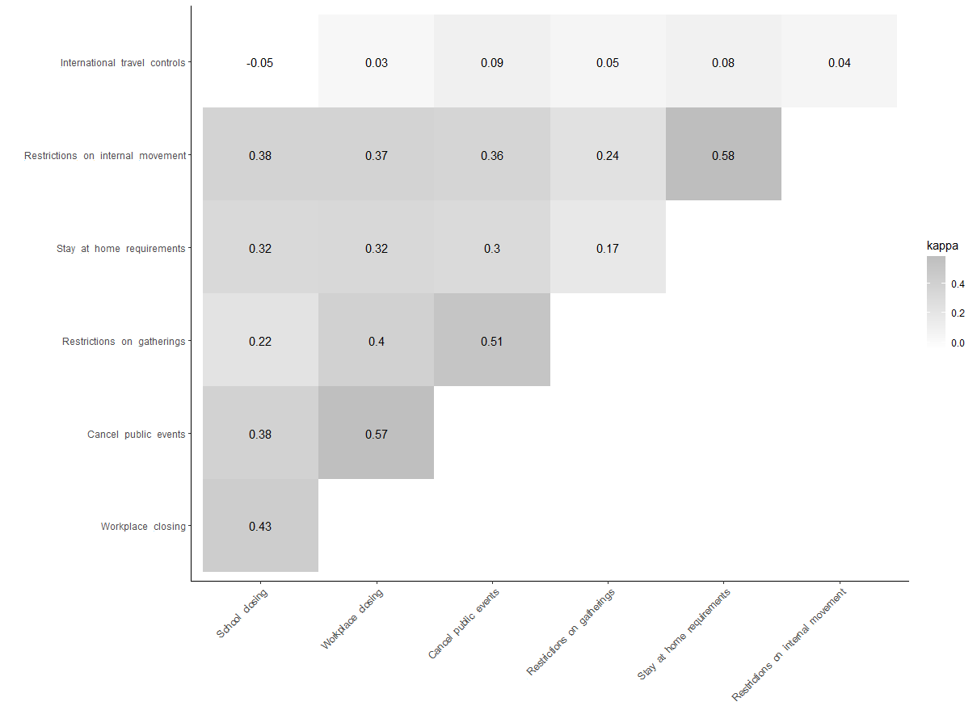
Supplemental Figure 3. Probability of Anxiety and Depressive Symptoms by Stringency Policy Score and Gender (43 countries, 2020).

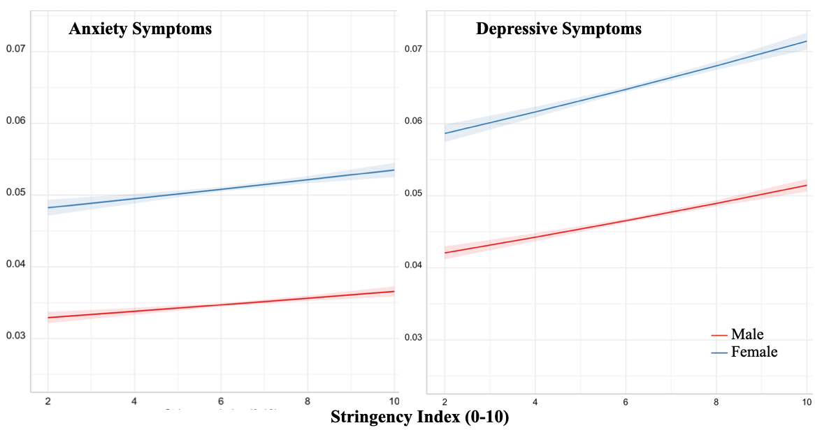

Supplemental Figure 4. Probability of Anxiety and Depressive Symptoms by Stringency Policy Score and Age (43 countries, 2020).

Supplemental Figure 5. Probability of Anxiety Symptoms by Stringency Policy Component and Gender (43 countries, 2020).
Supplemental Figure 6. Probability of Depressive Symptoms by Stringency Policy Component and Gender (43 countries, 2020).

Supplemental Figure 7. Probability of Anxiety Symptoms by Stringency Policy Component and Age (43 countries, 2020).

Supplemental Figure 8. Probability of Depressive Symptoms by Stringency Policy Component and Age (43 countries, 2020).

Supplemental Figure 9. Odds Ratios and 95% Confidence Intervals for Univariable (Single Policy Models) and Multivariable (All Policies Simultaneously) Associations of Non-Pharmaceutical Interventions with Anxiety Symptoms, Stratified by Gender (43 countries, 2020).

Supplemental Table 1. Odds Ratios and 95% Confidence Intervals for Associations of Non-Pharmaceutical Interventions with Anxiety and Depressive Symptoms, Stratified by Gender (43 countries, 2020).

Anxiety Symptoms |  |  | CI
 |  | OR | 2.50% | 97.50% | t-val | p
School closures | Male | 0.973 | 0.926 | 1.022 | -1.598 | 0.771
School closures | Female | 1.056 | 1.008 | 1.107 | 3.374 | 0.010
Workplace closures | Male | 1.002 | 0.952 | 1.056 | 0.133 | 1.000
Workplace closures | Female | 1.012 | 0.963 | 1.063 | 0.685 | 1.000
Cancellation of public events | Male | 0.956 | 0.895 | 1.022 | -1.958 | 0.485
Cancellation of public events | Female | 1.095 | 1.029 | 1.165 | 4.223 | 0.000
Restrictions on size of gatherings | Male | 1.048 | 0.992 | 1.107 | 2.466 | 0.167
Restrictions on size of gatherings | Female | 1.096 | 1.032 | 1.164 | 4.430 | 0.000
Stay-at-home requirements | Male | 1.092 | 1.054 | 1.132 | 7.143 | 0.000
Stay-at-home requirements | Female | 0.925 | 0.898 | 0.953 | -7.559 | 0.000
Restrictions on internal movement | Male | 0.905 | 0.868 | 0.944 | -6.871 | 0.000
Restrictions on internal movement | Female | 1.011 | 0.972 | 1.050 | 0.784 | 0.999
International travel controls | Male | 1.069 | 1.026 | 1.113 | 4.729 | 0.000
International travel controls | Female | 0.944 | 0.911 | 0.979 | -4.572 | 0.000

Depression Symptoms |  |  | CI
 |  | OR | 2.50% | 97.50% | t-val | p
School closures | Male | 1.016 | 0.975 | 1.058 | 1.112 | 0.979
School closures | Female | 1.089 | 1.046 | 1.134 | 6.102 | 0.000
Workplace closures | Male | 1.012 | 0.968 | 1.057 | 0.749 | 1.000
Workplace closures | Female | 0.983 | 0.940 | 1.029 | -1.075 | 0.984
Cancellation of public events | Male | 0.947 | 0.894 | 1.004 | -2.694 | 0.091
Cancellation of public events | Female | 1.035 | 0.979 | 1.095 | 1.785 | 0.626
Restrictions on size of gatherings | Male | 1.039 | 0.990 | 1.090 | 2.266 | 0.268
Restrictions on size of gatherings | Female | 1.092 | 1.034 | 1.153 | 4.653 | 0.000
Stay-at-home requirements | Male | 1.064 | 1.032 | 1.097 | 5.823 | 0.000
Stay-at-home requirements | Female | 1.003 | 0.976 | 1.030 | 0.287 | 1.000
Restrictions on internal movement | Male | 0.917 | 0.886 | 0.949 | -7.285 | 0.000
Restrictions on internal movement | Female | 1.067 | 1.032 | 1.104 | 5.560 | 0.000
International travel controls | Male | 1.038 | 1.003 | 1.076 | 3.108 | 0.026
International travel controls | Female | 0.961 | 0.930 | 0.993 | -3.519 | 0.006

Supplemental Table 2. Odds Ratios and 95% Confidence Intervals for Associations of Non-Pharmaceutical Interventions with Anxiety and Depressive Symptoms, Stratified by Age (43 countries, 2020).

Anxiety Symptoms |  |  | CI
 |  | OR | 2.50% | 97.50% | t-val | p
School closures | 18-24 | 1.031 | 0.983 | 1.082 | 1.879 | 0.552
School closures | ≥ 25 | 1.027 | 0.997 | 1.058 | 2.646 | 0.104
Workplace closures | 18-24 | 0.988 | 0.935 | 1.045 | -0.604 | 1.000
Workplace closures | ≥ 25 | 1.022 | 0.992 | 1.054 | 2.124 | 0.362
Cancellation of public events | 18-24 | 1.056 | 0.985 | 1.132 | 2.257 | 0.275
Cancellation of public events | ≥ 25 | 1.025 | 0.987 | 1.064 | 1.908 | 0.529
Restrictions on size of gatherings | 18-24 | 1.029 | 0.974 | 1.087 | 1.495 | 0.842
Restrictions on size of gatherings | ≥ 25 | 1.107 | 1.067 | 1.148 | 8.062 | 0.000
Stay-at-home requirements | 18-24 | 0.908 | 0.880 | 0.937 | -8.877 | 0.000
Stay-at-home requirements | ≥ 25 | 1.035 | 1.015 | 1.055 | 5.065 | 0.000
Restrictions on internal movement | 18-24 | 0.946 | 0.910 | 0.985 | -4.025 | 0.001
Restrictions on internal movement | ≥ 25 | 0.971 | 0.948 | 0.995 | -3.482 | 0.007
International travel controls | 18-24 | 1.013 | 0.979 | 1.047 | 1.084 | 0.984
International travel controls | ≥ 25 | 1.018 | 0.993 | 1.043 | 2.032 | 0.430

Depression Symptoms |  |  | CI
 |  | OR | 2.50% | 97.50% | t-val | p
School closures | 18-24 | 1.136 | 1.093 | 1.181 | 9.580 | 0.000
School closures | ≥ 25 | 1.018 | 0.993 | 1.044 | 2.071 | 0.401
Workplace closures | 18-24 | 0.995 | 0.951 | 1.041 | -0.342 | 1.000
Workplace closures | ≥ 25 | 1.009 | 0.981 | 1.037 | 0.900 | 0.997
Cancellation of public events | 18-24 | 0.947 | 0.894 | 1.004 | -2.706 | 0.088
Cancellation of public events | ≥ 25 | 1.034 | 0.998 | 1.071 | 2.739 | 0.080
Restrictions on size of gatherings | 18-24 | 1.070 | 1.021 | 1.122 | 4.141 | 0.000
Restrictions on size of gatherings | ≥ 25 | 1.079 | 1.045 | 1.115 | 6.760 | 0.000
Stay-at-home requirements | 18-24 | 0.942 | 0.917 | 0.967 | -6.616 | 0.000
Stay-at-home requirements | ≥ 25 | 1.075 | 1.056 | 1.094 | 11.963 | 0.000
Restrictions on internal movement | 18-24 | 0.982 | 0.951 | 1.013 | -1.715 | 0.687
Restrictions on internal movement | ≥ 25 | 1.014 | 0.993 | 1.035 | 1.889 | 0.545
International travel controls | 18-24 | 1.006 | 0.977 | 1.035 | 0.572 | 1.000
International travel controls | ≥ 25 | 1.006 | 0.984 | 1.029 | 0.831 | 0.999

Supplemental Text

Countries included in analyses: Argentina, Australia, Austria, Belgium, Brazil, Bulgaria, Canada, Chile, Colombia, Costa Rica, Czech Republic, Denmark, Estonia, Finland, France, Germany, Greece, Hungary, Iceland, India, Indonesia, Ireland, Israel, Italy, Japan, Latvia, Lithuania, Luxembourg, Mexico, Netherlands, New Zealand, Norway, Poland, Portugal, Romania, Russia, Slovenia, South Africa, Spain, Sweden, Switzerland, Turkey, United Kingdom

