Supplementary
Table S1. Introduction of health insurance schemes in China (China, 2011-2018).
Insurance | UEBMI | NCMS | URBMI | URRBMI
Implementation year | 1998 | 2003 | Piloted in 2007 and implemented in 2010 nationwide | Piloted in several provinces in 2008 and implemented in 2016 nationwide
Target population | Urban employees and retirees | Rural residents | Urban residents without formal employment | Urban and rural residents without formal employment
Principle of participation | Mandatory | Voluntary | Voluntary | Voluntary
Funding | Payroll tax (6% from employers, and 2% from employees) | Individual contribution, collective support, and government subsidies | Individual contributions and government subsidies | Individual contributions and government subsidies
Number of people insured | 354.31 million (In 2021) | 670.29 million (In 2015) | 376.89 million (In 2015) | 1.0086 billion (In 2021)
Risk-pooling | Municipal/City level | County level | Municipal/City level | Municipal/City level
Per capita financing (RMB) | — | 490.3 (In 2015) | — | 889 (In 2021)
Insurance benefits | Covered outpatient and inpatient care | Mainly covered inpatient care, supplemented with outpatient care for catastrophic diseases and generous outpatient care | Mainly covered inpatient care, supplemented with outpatient care for catastrophic diseases | Mainly covered inpatient care, supplemented with outpatient care with serious illness and generous outpatient care
Inpatient reimbursement rates | 84.4% (In 2021) | — | — | 69.3% (In 2021)
Note: Data are from the National Health Statistics Annual Report; The national statistical bulletin on the development of basic medical insurance.
Abbreviations: NCMS, the New Cooperative Medical Scheme; URBMI, the Urban Resident Basic Medical Insurance; URRBMI, Urban and Rural Resident Basic Medical Insurance; UEBMI, Urban Employee Basic Medical Insurance.

Text S1.
In 2016, the Chinese government officially issued “Opinions of the State Council on Integrating the Medical Insurance System for Urban and Rural Residents” (the “Opinions”) and decided to merge NCMS and URBMI nationwide and established Urban and Rural Resident Basic Medical Insurance (URRBMI). To achieve this objective, the “Opinions” provided guidance on 6 key areas, which included integrating the coverage of the medical insurance system, the fund-raising policies, the benefits, the health insurance directory, and the management of funds and selected agencies.
Actually, the implementation details are usually decided at a local level. In 2022, the national funding standard for URRBMI is 960 yuan per capita, of which 350 yuan is paid by individuals and 610 yuan is subsidized by the government. The actual funding standard of each province /municipality would be adjusted and formulated according to the local economic development level and demographic structure on the basis of meeting the national standard. For example, in Beijing, the funding standard for residents aged 19-59 is 3,665 yuan, of which the individual payment is 885 yuan and the financial subsidy is 2,780 yuan, which is much higher than the national standard. The funding standards in Fujian Province and Henan Province are set in accordance with national standards.

Table S2. Description of the URRBMI implementation in China and classification of treatment group and control group (China, 2011-2018).

Provinces /Municipalities | Time for implementation
Treatment group
Qinghai | June 2016
Fujian | 2016
Hebei | January 2017
inner Mongolia | January 2017
Shanghai | January 2016
Hubei | June 2017
Xinjiang | June 2017
Jiangxi | 2017
Shanxi | January 2017
Anhui | 2017
Henan | January 2017
Hunan | January 2017
Yunnan | January 2017
Guangxi | January 2017
Sichuan | January 2017
Gansu | January 2017
Jilin | January 2017
Shaanxi | January 2017
Control group
Jiangsu | January 2018
Heilongjiang | January 1^{st,} 2018
Guizhou | January 2018
Beijing | January 2018
Liaoning | January 2020
Group of implemented URRBMI before 2016
Chongqing | 2009
Tianjin | January 2010
Guangdong | October 2012
Shandong | September 2014
Zhejiang | December 2014
Note: The CHARLS national survey was performed from July to August and reported inpatient utilization in the last year. Therefore, we used the one-year lagged adoption of URRBMI.
Data resource: The official website of the government of each province in China.

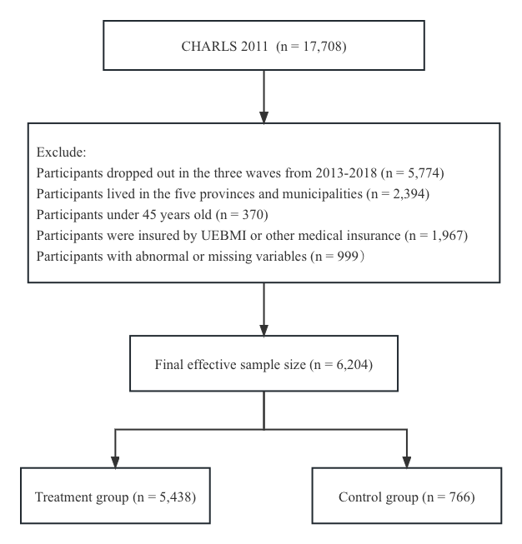
Figure S1. Study flow chart of sample selection (China, 2011-2018).
Note: We treated this longitudinal survey as panel data. The final sample of 24,816 observations from the 6204 participants.

Table S3. Definition and coding of variables (China, 2011-2018).
Variables | Definition
Dependent variables
Probability of outpatient visits | No = 0; Yes = 1
Number of outpatient visits | Continuous variables
Probability of outpatient visits | No = 0; Yes = 1
Number of inpatient visits | Continuous variables
Control variables
Predisposing characteristics
Gender | Female = 0; Male = 1
Age | 45-59 years = 0; ≥60 years = 1
Marital status | Otherwise (separated, divorced, widowed, never married and marital status cohabitated) = 0; Married = 1;
Education | Illiterate = 0; Primary or below = 1; Junior or above = 2
Enabling resources
Residence | Rural = 0; Urban = 1
Annual personal income | Continuous variables
Need factors
Chronic | No = 0; At least has one chronic disease (e.g., hypertension, dyslipidemia, diabetes or high blood sugar); Yes = 1
Self-reported health status | Good = 0; Fair = 1; Poor = 2

Table S4. Descriptive statistics of the dependent variables (China, 2011-2018).
Variables | Treatment group (n=5,438) |  |  | Control group (n=766)
Variables | n | % |  | n | %
Panel A: 2011
Number (percentage) of respondents making outpatient visits in the last month
 | 1,179 | 21.68 |  | 101 | 13.19
Number (percentage) of respondents making inpatient visits in the last month
 | 442 | 8.13 |  | 46 | 6.01
Panel B: 2018
Number (percentage) of respondents making outpatient visits in the last month
 | 949 | 17.45 |  | 95 | 12.40
Number (percentage) of respondents making inpatient visits in the last month
 | 1,054 | 19.38 |  | 110 | 14.36

Table S5. Descriptive statistics of the dependent variables (China, 2011-2018).
Variables | Treatment group (n=5,438) |  |  | Control group (n=766)
Variables | Mean | SD |  | Mean | SD
Panel A: 2011
Mean number of outpatient visits
 | 0.467 | 1.399 |  | 0.210 | 0.676
Mean number of inpatient visits
 | 0.112 | 0.513 |  | 0.068 | 0.290
Panel B: 2018
Mean number of outpatient visits
 | 0.396 | 1.420 |  | 0.225 | 0.846
Mean number of inpatient visits
 | 0.313 | 0.815 |  | 0.209 | 0.601

Table S6. Heterogeneity Analysis (China, 2011-2018).
 | Probability of Outpatient Visits |  |  | Number of Outpatient Visits |  |  | Probability of Inpatient Visits |  |  | Number of Inpatient Visits
 | Odds ratio | 95%CI |  | Coefficients | SE |  | Odds ratio | 95%CI |  | Coefficients | SE
Panel A: urban residents
URRBMI | 0.752** | (0.475, 1.193) |  | -0.054 | (0.046) |  | 0.842 | (0.521, 1.360) |  | 0.034 | (0.041)
Control variables | Yes |  |  | Yes |  |  | Yes |  |  | Yes
Time effect | Yes |  |  | Yes |  |  | Yes |  |  | Yes
Individual effect | Yes |  |  | Yes |  |  | Yes |  |  | Yes
R²/ Pseudo R² | 0.071 |  |  | 0.050 |  |  | 0.098 |  |  | 0.078
Panel B: rural residents
URRBMI | 0.821 | (0.578, 1.166) |  | -0.122*** | (0.033) |  | 1.182 | (0.819, 1.707) |  | 0.039 | (0.025)
Control variables | Yes |  |  | Yes |  |  | Yes |  |  | Yes
Time effect | Yes |  |  | Yes |  |  | Yes |  |  | Yes
Individual effect | Yes |  |  | Yes |  |  | Yes |  |  | Yes
R²/ Pseudo R² | 0.067 |  |  | 0.045 |  |  | 0.087 |  |  | 0.062
Panel C: 45-59 years old
URRBMI | 0.887 | (0.534, 1.472) |  | -0.031 | (0.050) |  | 0.869 | (0.496, 1.520) |  | 0.007 | (0.036)
Control variables | Yes |  |  | Yes |  |  | Yes |  |  | Yes
Time effect | Yes |  |  | Yes |  |  | Yes |  |  | Yes
Individual effect | Yes |  |  | Yes |  |  | Yes |  |  | Yes
R²/ Pseudo R² | 0.0736 |  |  | 0.051 |  |  | 0.090 |  |  | 0.058
Panel D: 60 years old and above
URRBMI | 0.780*** | (0.533, 1.099) |  | -0.126*** | (0.036) |  | 1.166 | (0.823, 1.653) |  | 0.049** | (0.020)
Control variables | Yes |  |  | Yes |  |  | Yes |  |  | Yes
Time effect | Yes |  |  | Yes |  |  | Yes |  |  | Yes
Individual effect | Yes |  |  | Yes |  |  | Yes |  |  | Yes
R²/ Pseudo R² | 0.065 |  |  | 0.044 |  |  | 0.077 |  |  | 0.064
Note: Odds ratios (ORs) are reported for logit models, whereas coefficients are reported for linear regression models. Significance levels *P < 0.1; **P < 0.05; ***P < 0.01. Robust standard errors are reported in brackets and clustered by provinces. Additional controls included the variables of gender, age, marital status, education status, personal income, chronic disease, and self-reported health status. All regressions control for time-fixed effect and province-fixed effect.
Abbreviations: URRBMI, Urban and Rural Resident Basic Medical Insurance.

Table S7. Robustness analysis-The effects of URRBMI integration on healthcare utilization using PSM-DID model (China, 2011-2018).
 | Probability of Outpatient Visits |  |  | Number of Outpatient Visits |  |  | Probability of Inpatient Visits |  |  | Number of Inpatient Visits
 | Odds Ratios | 95%CI |  | Coefficients | SE |  | Odds Ratios | 95%CI |  | Coefficients | SE
URRBMI | 0.815** | (0.665, 1.000) |  | -0.101*** | (0.026) |  | 1.005 | (0.768, 1.315) |  | 0.036** | (0.015)
Age (Ref. 45-59 years) | 0.942 | (0.868, 1.021) |  | -0.011 | (0.014) |  | 1.330*** | (1.187, 1.490) |  | 0.047*** | (0.012)
Gender (Ref. Female) | 0.820*** | (0.733, 0.919) |  | -0.082*** | (0.027) |  | 0.989 | (0.920, 1.064) |  | 0.003 | (0.008)
Marital status (Ref. Otherwise) | 0.946 | (0.855, 1.047) |  | 0.006 | (0.051) |  | 0.872** | (0.770, 0.988) |  | -0.028* | (0.016)
Education (Ref. Illiterate)
Primary or below | 1.044 | (0.935, 1.166) |  | 0.007 | (0.021) |  | 1.088* | (0.997, 1.188) |  | 0.010 | (0.013)
Junior or above | 1.120* | (0.988, 1.270) |  | 0.021 | (0.018) |  | 1.121* | (0.993, 1.265) |  | 0.015 | (0.012)
Residence (Ref. Rural) | 0.903** | (0.825, 0.988) |  | -0.011 | (0.023) |  | 1.176*** | (1.064, 1.300) |  | 0.020* | (0.011)
Annual personal income | 1.006 | (0.998, 1.014) |  | 0.000 | (0.002) |  | 0.992* | (0.982, 1.001) |  | -0.002* | (0.001)
Chronic disease (Ref. No) | 1.744*** | (1.591, 1.912) |  | 0.170*** | (0.021) |  | 1.874*** | (1.757, 1.999) |  | 0.092*** | (0.011)
Self-reported health status (Ref. Good)
Fair | 1.852*** | (1.677, 2.045) |  | 0.136*** | (0.020) |  | 1.533*** | (1.367, 1,718) |  | 0.034*** | (0.006)
Poor | 3.951*** | (3.607, 4.328) |  | 0.583*** | (0.061) |  | 3.983*** | (3.291, 4.822) |  | 0.294*** | (0.020)
Time effect | Yes |  |  | Yes |  |  | Yes |  |  | Yes
Province effect | Yes |  |  | Yes |  |  | Yes |  |  | Yes
Constant | 0.241*** | (0.196, 0.296) |  | 0.170*** | (0.045) |  | 0.013*** | (0.010, 0.018) |  | 0.031 | (0.024)
R²/ Pseudo R² | 0.067 |  |  | 0.046 |  |  | 0.088 |  |  | 0.064
Note: Odds Ratios (ORs) are reported for logit models, whereas coefficients are reported for linear regression models. Significance levels *P < 0.1; **P < 0.05; ***P < 0.01. Robust standard errors are reported in brackets and clustered by provinces. All regressions control for time-fixed effect and province-fixed effect.
Abbreviations: URRBMI, Urban and Rural Resident Basic Medical Insurance.

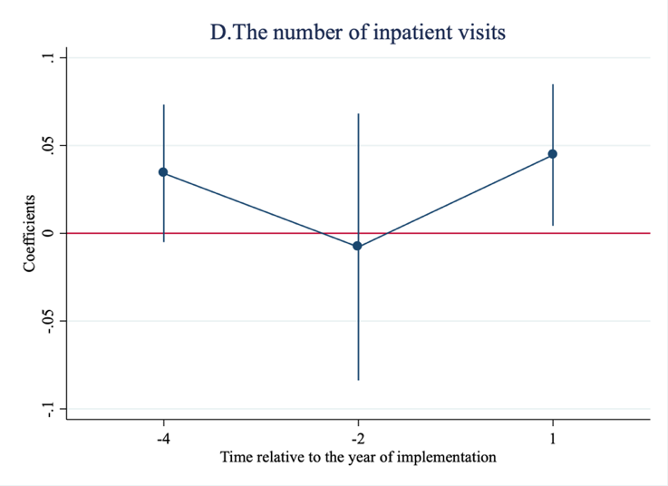
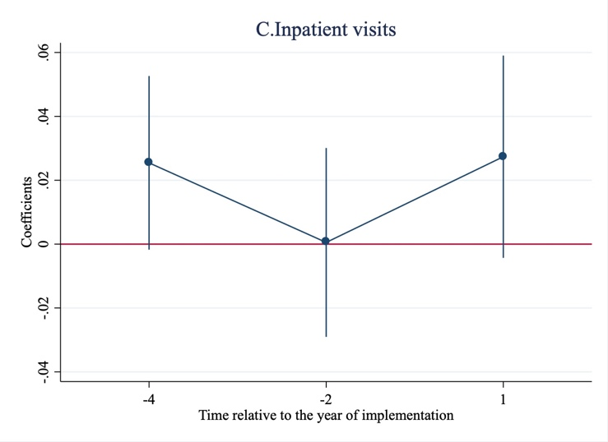
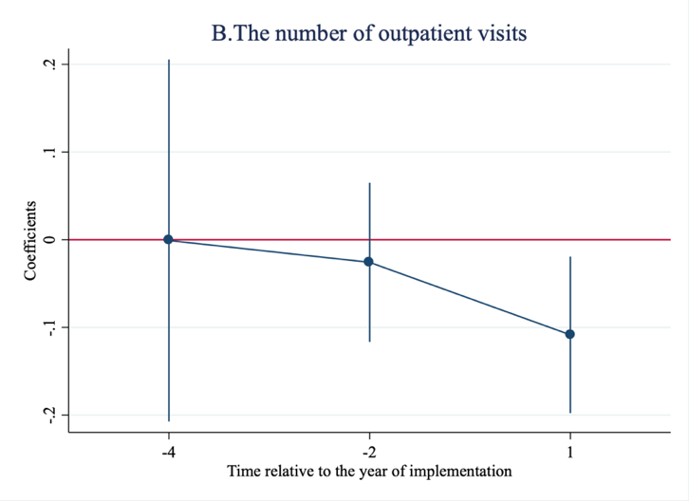
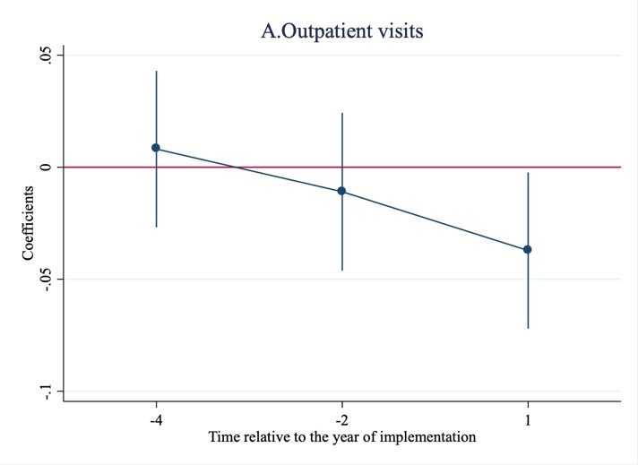

Figure S2. Common trend test (China, 2011-2018).

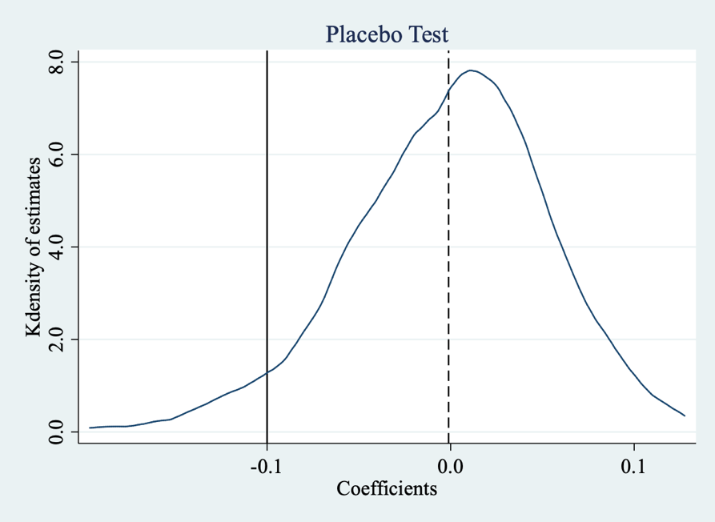

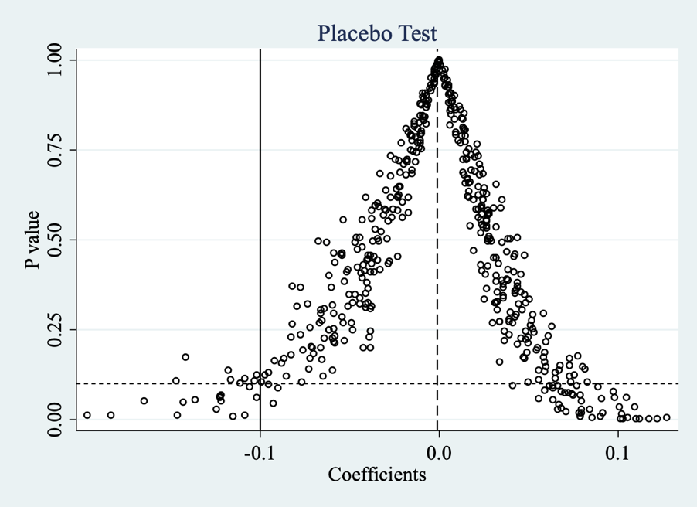

Figure S3. Placebo Test (China, 2011-2018).

Note: We took the placebo test for the number of outpatient visits.

