Supplementary materials

Figure S1. Distribution of EQ-5D-3L index scores in both study groups
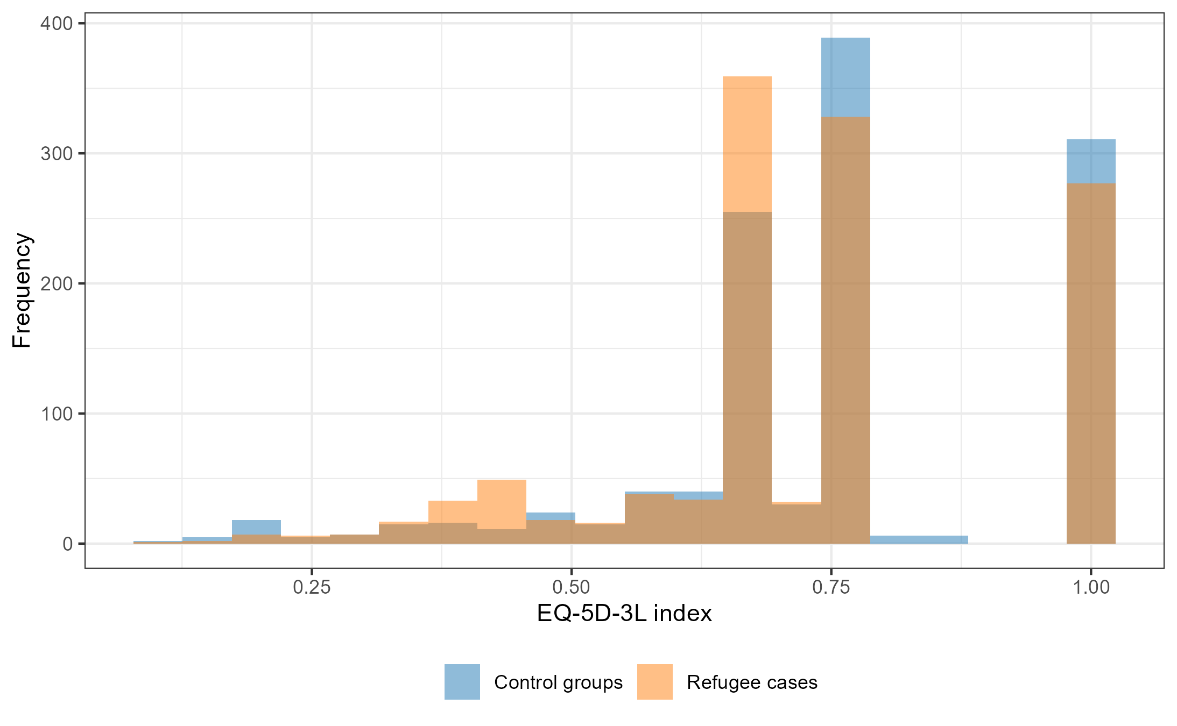

Table S2. Comparison of Tobit and OLS regression models (p < 0.05 in bold) describing the association between predictor variables and EQ-5D index score
 | Model 1 (univariate) estimates |  | Model 2 estimates |  | Model 3 estimates |  | Model 4 estimates |  | Model 5 (final) estimates
 | Tobit | OLS | Tobit | OLS | Tobit | OLS | Tobit | OLS | Tobit | OLS
Refugees vs controls | -0.028 | -0.022 | -0.024 | -0.020 | -0.001 | -0.001 | -0.009 | -0.009 | -0.017 | -0.015
Sex: female vs men | -0.049 | -0.035 | -0.039 | -0.275 | -0.030 | -0.020 | -0.013 | -0.010 | -0.017 | -0.012
Age (cont.) | -0.003 | -0.002 | -0.003 | -0.002 | -0.002 | -0.002 | -0.002 | -0.001 | -0.002 | -0.001
Marital: married/cohabiting vs single | 0.009 | 0.010 | 0.034 | 0.030 | 0.029 | 0.026 | 0.014 | 0.013 | - | -
Marital: divorced/separated/widowed vs single | -0.078 | -0.060 | -0.028 | -0.021 | -0.017 | -0.011 | -0.015 | -0.011 | - | -
Education: secondary/vocational vs primary | -0.058 | -0.039 | -0.045 | -0.029 | -0.054 | -0.036 | -0.034 | -0.022 | - | -
Education: tertiary vs primary | -0.044 | -0.026 | -0.026 | -0.012 | -0.051 | -0.032 | -0.034 | -0.020 | - | -
Income: 900-1299 vs <900 | 0.048 | 0.040 | - | - | 0.016 | 0.014 | 0.013 | 0.011 | - | -
Income: 1300-1700 vs <900 | 0.080 | 0.063 | - | - | 0.032 | 0.025 | 0.023 | 0.017 | - | -
Income: >1700 vs <900 | 0.096 | 0.077 | - | - | 0.021 | 0.019 | 0.020 | 0.016 | - | -
Comfort: coping vs well off | -0.066 | -0.049 | - | - | -0.050 | -0.036 | -0.005 | -0.003 | -0.010 | -0.008
Comfort: finding it difficult vs well off | -0.160 | -0.125 | - | - | -0.136 | -0.107 | -0.036 | -0.030 | -0.046 | -0.037
Comfort: very difficult vs well off | -0.240 | -0.202 | - | - | -0.202 | -0.171 | -0.041 | -0.041 | -0.053 | -0.052
Self-rated health: average vs good | -0.205 | -0.163 | - | - | - | - | -0.129 | -0.104 | -0.129 | -0.104
Self-rated health: poor vs good | -0.402 | -0.357 | - | - | - | - | -0.252 | -0.234 | -0.254 | -0.237
Stress: yes vs no | -0.210 | -0.177 | - | - | - | - | -0.067 | -0.062 | -0.068 | -0.063
Depressiveness: yes vs no | -0.217 | -0.179 | - | - | - | - | -0.077 | -0.063 | -0.077 | -0.064
Overtiredness: yes vs no | -0.219 | -0.169 | - | - | - | - | -0.098 | -0.071 | -0.098 | -0.071
(Intercept) | na | na | 0.938 | 0.865 | 0.975 | 0.891 | 1.046 | 0.962 | 1.044 | 0.967

